**IMPLEMENTING CRM FOR RESULT TRACKING OF A CANDIDATE WITH INTERNAL MARKS**

1. **Introduction**
   1. Overview

Implementing a CRM (Customer Relationship Management) system for result tracking of a candidate with internal marks would involve creating a database that contains the necessary information about each candidate and their internal marks. The CRM system would need to have the capability to track each candidate's progress through the different stages of the result tracking process, such as the initial entry of internal marks, verification of those marks, and finalization of the result.

* 1. Purpose
* By using a CRM system, all the data related to a candidate's performance can be stored in a centralized database. This can include their internal marks, attendance, assignments, and other relevant information. This makes it easier for the faculty and staff to access the data and track the progress of the candidate**.**
* A CRM system can help to create personalized communication with the candidates. This can include automated messages, reminders, and notifications related to their academic performance. It can also be used to send congratulatory messages or encouragement to candidates who are performing well.
* A CRM system can also improve collaboration between different departments or teams involved in the candidate's academic progress. For example, the faculty, academic advisors, and administrative staff can all access the same data and communicate with each other to provide the best support to the candidate.
* A CRM system can generate reports and analytics related to a candidate's performance. This can include graphs and charts that display the candidate's progress over time, their performance in different subjects, and their overall academic performance. These reports can be useful for faculty and staff in making decisions related to the candidate's academic progress.

1. **Problem Definition & Design Thinking**
   1. Empathy Map

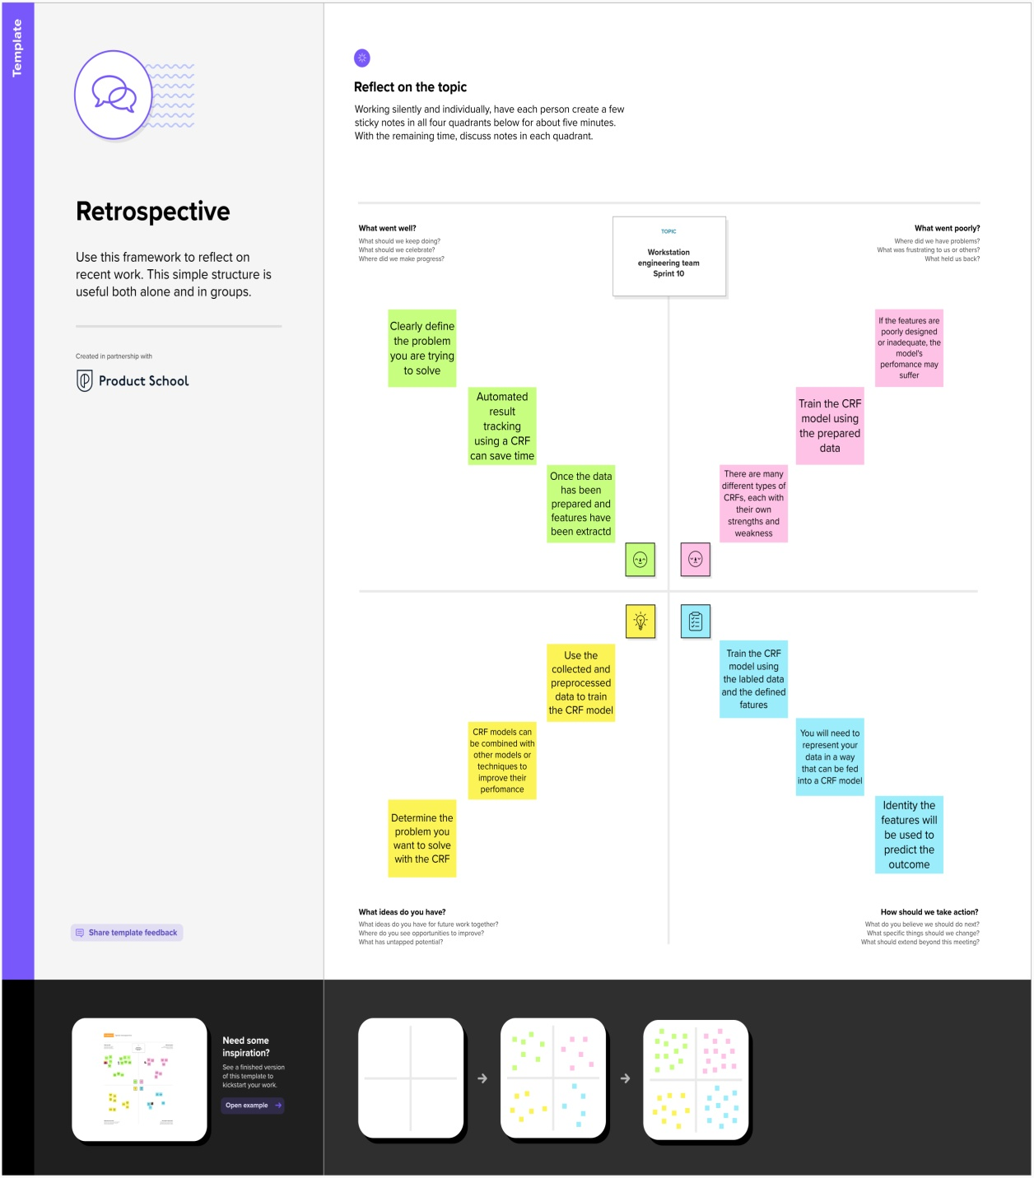

* 1. Ideation & Brainstrom Map

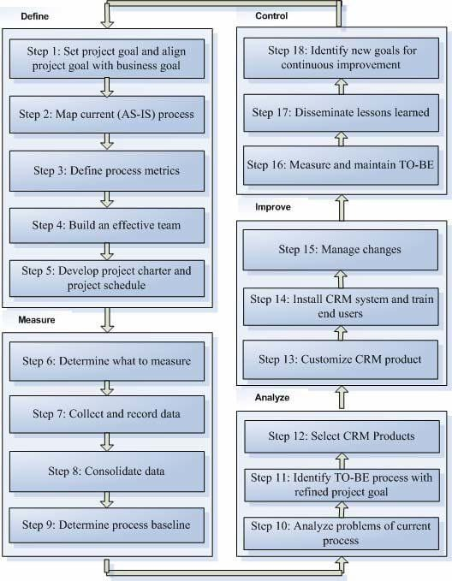

1. **Result**
   1. Data Model

|  |  |
| --- | --- |
| **Object Name** | **Fields in the Object** |
| Internal Results | |  |  | | --- | --- | | **Field label** | **Data type** | | Candidate Id | Text | | Course Id | Text | | Internal Results Name | Text | | Marks | Number | |
| Lecturer Details | |  |  | | --- | --- | | **Field label** | **Data type** | | Course | Lookup | | Course Id | Text | | Lecturer Details Name | Text | | Lecturer Name | Text | | Lecturer Role | Text | |
| Semester | |  |  | | --- | --- | | **Field label** | **Data type** | | Semester | Text | | Semester | Lookup | | Semester Name | Text | |
| Candidate | |  |  | | --- | --- | | **Field label** | **Data type** | | Candidate | Lookup | | Candidate Name | Text | | Candidate Id | Text | | Semester Name | Text | |
| Course Details | |  |  | | --- | --- | | **Field label** | **Data type** | | Course Details | Text | | Course Details Name | Text | |

* 1. Activity & Screenshot
* Home Page of Salesforce Account

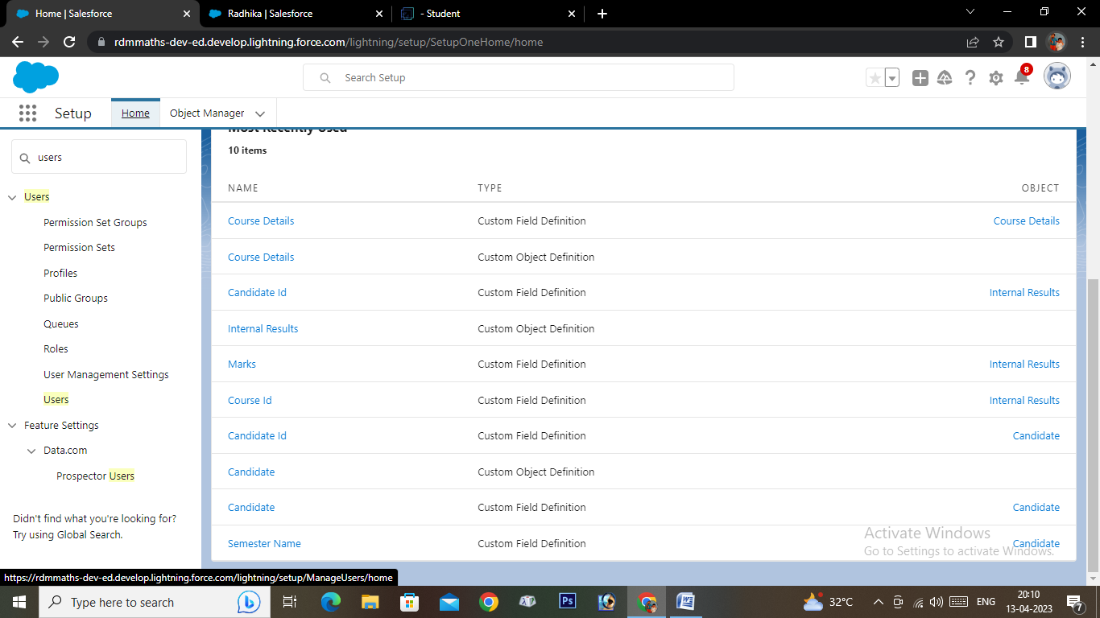

* **Custom Objects**
* **Course details**

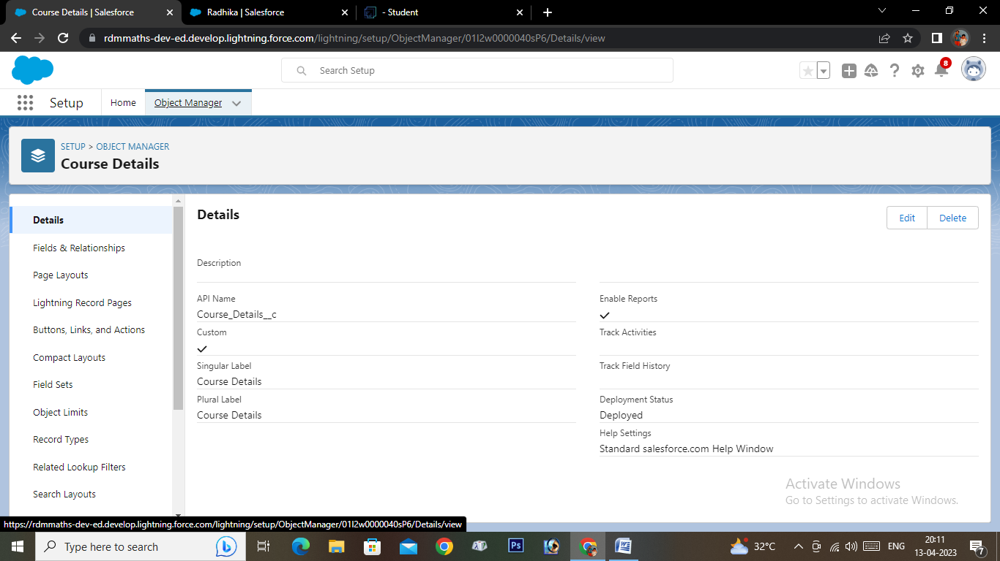

* **Lecturer Details**

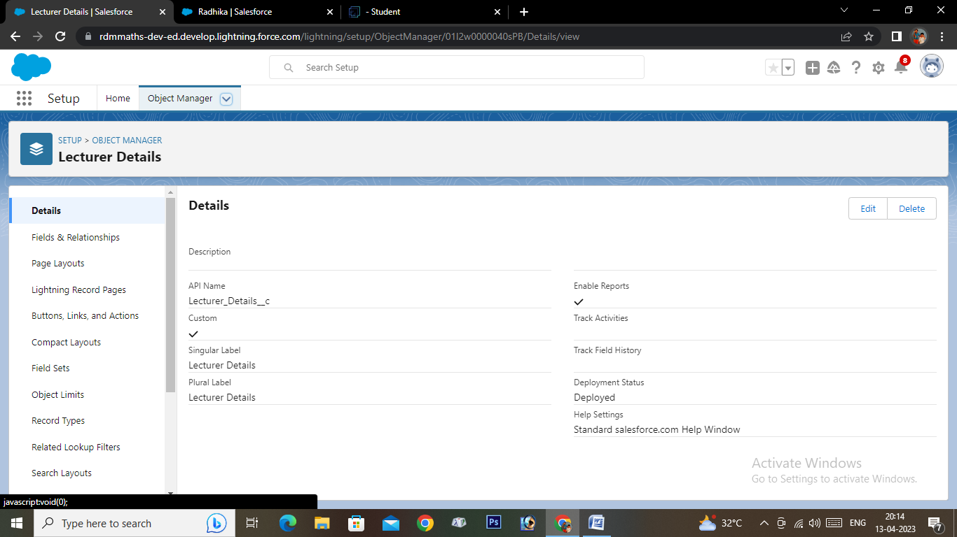

* **Semester**

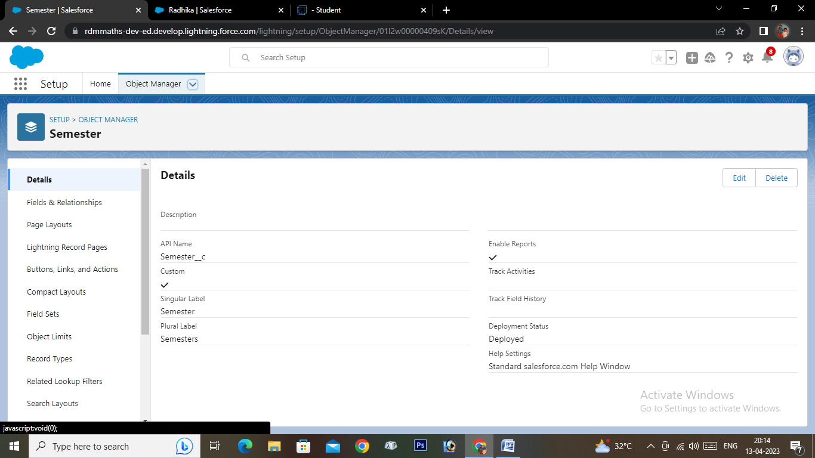

* **Candidate**

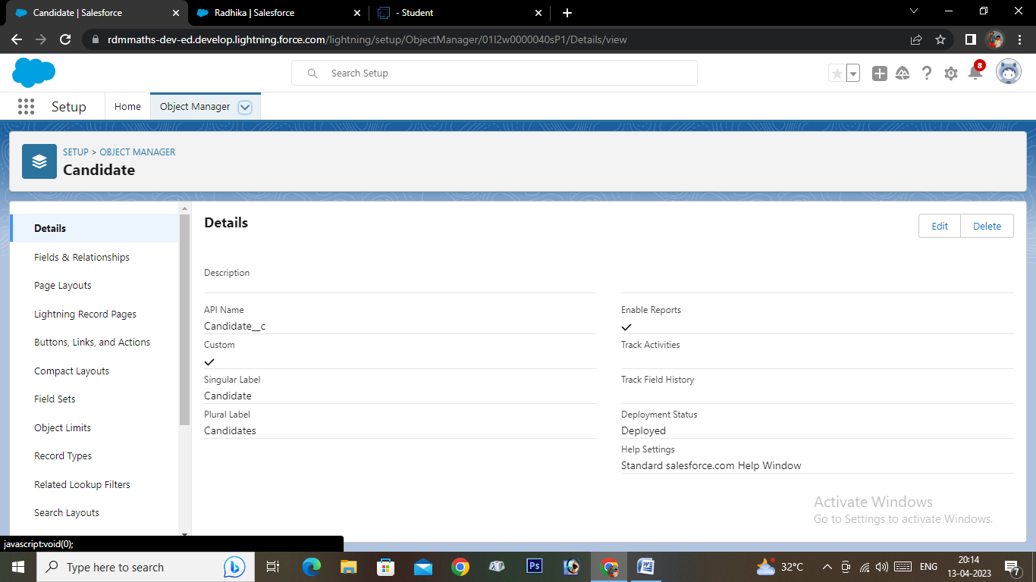

* **Internal Details**

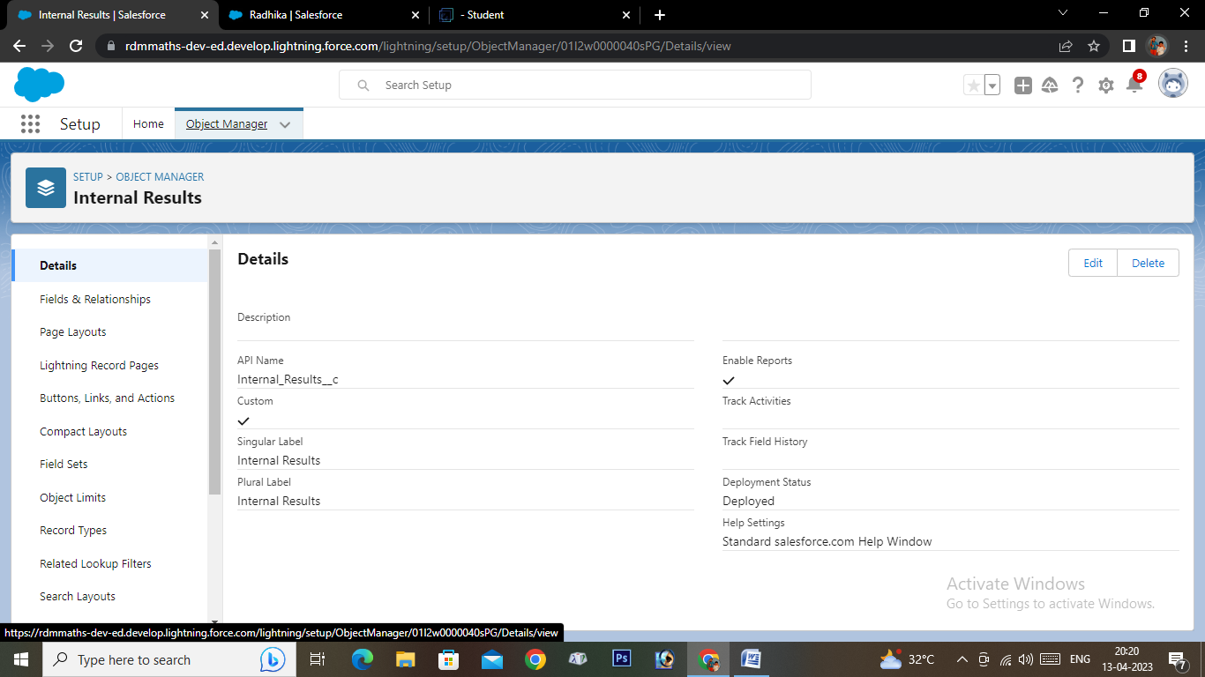

* **Users**

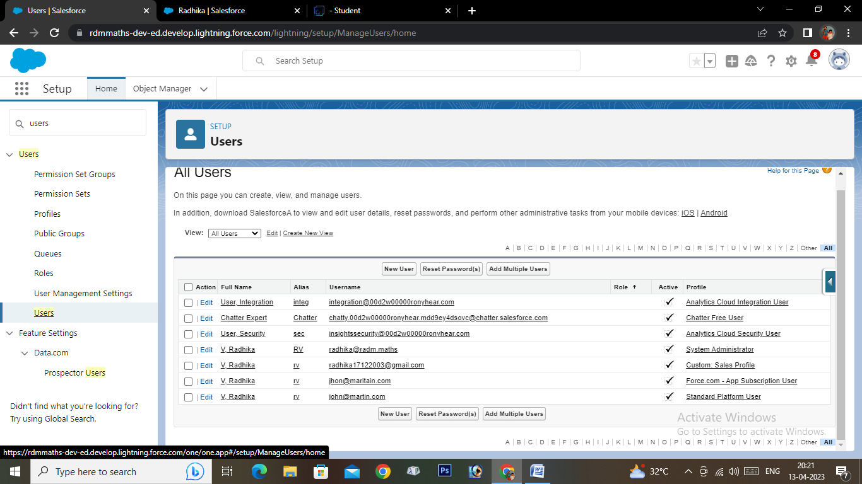

* **Reports**

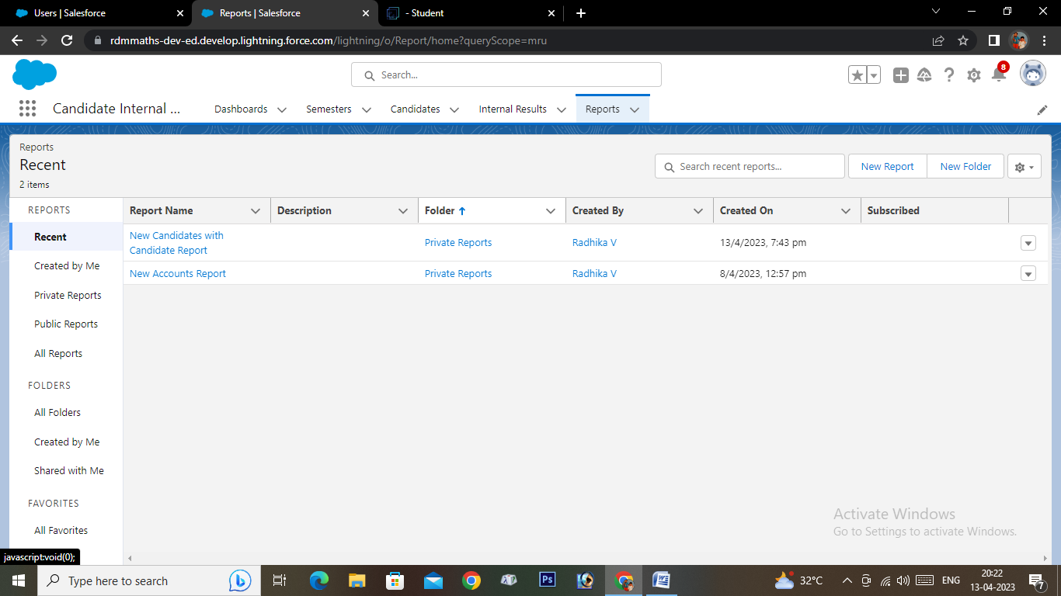

* **Dashboard**

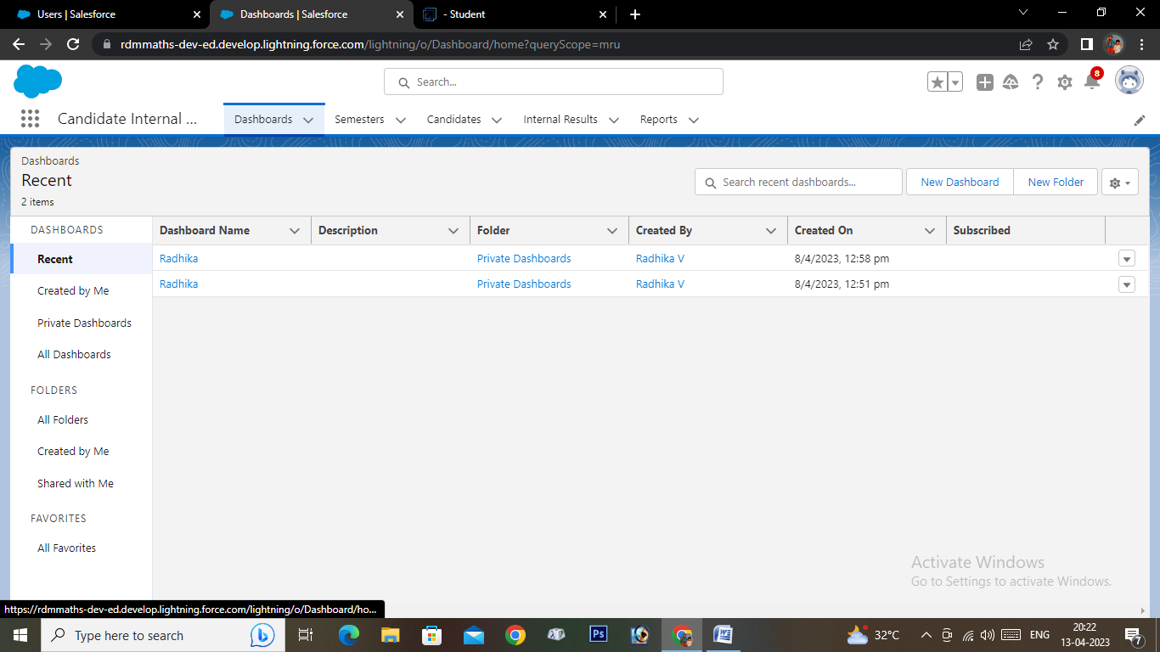

1. **Trailhead Profile Public URL**

* **Team Leader -** [**https://trailblazer.me/id/trailradhika1712**](https://trailblazer.me/id/trailradhika1712)
* **Team Member 1 -** <https://trailblazer.me/id/ajitt5>
* **Team Member 2 -** <https://trailblazer.me/id/vpechimuthu>
* **Team Member 3 -** <https://trailblazer.me/id/skumar9247>

1. **Advantages & Disadvantages**

|  |  |
| --- | --- |
| **Advantages** | **Disadvantages** |
| A CRM system can help automate the result tracking process, saving time and reducing the potential for errors. | Implementing a CRM system can be costly, especially for small organizations with limited resources. |
| A CRM system can provide a centralized database for all candidate information, including internal marks, allowing for easy access and analysis of data. | Storing sensitive candidate information in a CRM system requires robust security measures to prevent unauthorized access. |
| CRM systems can generate customizable reports,which can provide valuable insights into candidate performance, allowing for informed decision-making. | Implementing and maintaining a CRM system requires technical expertise and ongoing support, which can be challenging for some organizations. |

1. **Applications**

* Educational institutions can use a CRM to track the performance of their students, manage their academic records, and communicate with them regarding their progress.
* Recruitment agencies can use a CRM to track the progress of job candidates, manage their resumes, and communicate with them regarding their interviews and job offers.
* HR departments can use a CRM to track the performance of their employees, manage their employment records, and communicate with them regarding their career development.
* Sales and marketing departments can use a CRM to track the performance of their leads and customers, manage their sales and marketing activities, and communicate with them regarding their needs and preferences.

1. **Conclusion**

Implementing a CRM (Customer Relationship Management) system for tracking candidate results with internal marks solution can provide numerous benefits for educational institutions, recruitment agencies, HR departments, sales and marketing teams, and other industries that require managing relationships with people.

By using a CRM, organizations can track and analyze candidate performance, manage their records, communicate with them regarding their progress, and improve their overall experience. With the help of a CRM, organizations can also streamline their processes, increase efficiency, and make data-driven decisions.

In conclusion, implementing a CRM system for result tracking of a candidate with internal marks can be a valuable investment for any organization that wants to enhance its candidate management processes and improve its relationships with stakeholders.

1. **Feature Scope**

* Educational institutions can use a CRM to track the performance of their students, manage their academic records, and communicate with them regarding their progress.
* Recruitment agencies can use a CRM to track the progress of job candidates, manage their resumes, and communicate with them regarding their interviews and job offers.
* HR departments can use a CRM to track the performance of their employees, manage their employment records, and communicate with them regarding their career development.
* Sales and marketing departments can use a CRM to track the performance of their leads and customers, manage their sales and marketing activities, and communicate with them regarding their needs and preferences.